



FREEZER CHEST

LONDON Series

Data sheet

Operating manual

Volzhsk
Form 2021

TABLE OF CONTENTS

- General Product Information.
2. Basic Technical Data and Specifications.
- Scope of Supply.
- Unpacking, Assembly and Commissioning.
- Electric Connections. Safety.
- Operating and Maintenance Manual.
- Storage, Transport and Handling.
- Acceptance and Packing Certificate.
- Warranty.
- Disposal.

1. GENERAL PRODUCT INFORMATION

1.1. LONDON Series freezer chest is designed for display, sale and temporary storage of precooled or frozen products and convenience foods at trade and public catering facilities. The freezer chest is not intended for freezing fresh foods.
1.2. The freezer chest complies with the requirements of TR CU 010/2011 On Safety of Machines and Equipment, GOST 23833, GOST R 52161.1, GOST R 52161.2.24, as well as the requirements of TR CU 004/2011 On Safety of Low-Voltage Equipment, GOST 14254 and TR CU 020/2011 Electromagnetic Compatibility, GOST R 51318.14.1, GOST R 51318.14.2, GOST R 51317.3.2, GOST R 51317.3.3.
1.3. Freezer chests are manufactured in accordance with the requirements of GOST 23833 in Climatic Modification U (moderate) Environmental Class 3 in accordance with GOST 15150 for operation in ambient temperatures from 12 °С to 25 С and maximum relative humidity 50%.
1.4. The freezer chest is manufactured to provide the following operating temperature range:
LM – medium temperature chest: 0/+10°С
LL – low temperature chest: -23/-18°С
LU – universal chest: -6/+6°С

Product designations.
• Chest LM 1-185, LL 1-185, LU 1-185, LL 1-210, LL 1-210, LU 1-210, LM 1-250, LL 1-250,
LU 1-250.

Upon request, the chests can be manufactured with additional lattice partitions, height-adjustable shelves and uncooled superstructures or light boxes.
- BASIC TECHNICAL DATA AND SPECIFICATIONS
2.1. Basic technical data are provided in Table 1.
Table 1
No. | Characteristic | LM1-185 | LL1-185 | LU1-185 | LM1-210 | LL1-210 | LU1-210 | LM1-250 | LL1-250 | LU1-250
1 | Total cooled volume, l | 790 |  |  | 910 |  |  | 1100
2 | Maximum temperature,С | 0/+10 | -18/-23 | +6/-6 | 0/+10 | -18/-23 | +6/-6 | 0/+10 | -18/-23 | +6/-6
3 | Effective cooled volume, l | 530 |  |  | 630 |  |  | 740
4 | Max daily power  consumption, kW∙h | 3 | 7.7 | 5.0 | 3 | 7.7 | 5.1 | 4 | 8.2 | 6.2
5 | Max current, A | 4.8 |  |  | 5.5 |  |  | 7.2
6 | Dimensions, mm  Height (adjustable feet) Width  Depth | 89320  18585  8805 |  |  | 89320  21055  8805 |  |  | 89320  25055  8805
7 | Max display rack load bearing capacity | 150 kg/m2
8 | Cooling medium | R 290 refrigerant
9 | Noise level | <69 dB(A)
10 | Max net weight, kg | 117 |  |  | 147 |  |  | 177
11 | Max gross weight, kg, (with max components) | 174 |  |  | 204 |  |  | 234
12 | Power supply parameters, V/Ph/Hz | 220/1/50

- SCOPE OF SUPPLY
3.1. Scope of supply is provided in Table 2.
Table 2
Components | Quantity, pcs
Components | LM(L)(U)1-185 | LM(L)(U)1-210 | LM(L)(U)1-250
1. Chest | 1 | 1 | 1
2. Front wall | 1 | 1 | 1
3. Back wall | 1 | 1 | 1
4. Left wall | 1 | 1 | 1
5. Right wall | 1 | 1 | 1
6. Floor rack | 2 | 3 | 3
7. Shelf | 1 | 1 | 1
8. Hanger
9. Partition
10. Plastic scraper | 1 | 1 | 1
11. Waste container | 1 | 1 | 1
12. Support foot | 4 | 6 | 6
13. Operating manual | 1 | 1 | 1
14. Packaging | 1 | 1 | 1
15. Special lubrication | 1 | 1 | 1

- UNPACKING, ASSEMBLY AND COMMISSIONING
4.1. Carefully remove the package from the product, taking all necessary precautions against impacting the external front surfaces of the product.
IMPORTANT Risk of suffocation. Packaging materials plastic film, polystyrene foam are dangerous for children. Keep packaging materials out of reach of children.
4.2. Remove the components and documents from inside the product. Red the Data Sheet. Verify the completeness of the supplied product.
4.3. Remove the product from the wooden pallet, unscrew the bolts securing the product to the pallet.
4.4. The product may only be moved within the premises in accordance with the handling scheme indicated on the plate.
4.5. DO NOT install the product in places:
4.5.1. in close proximity (less than 1 m) to heat sources (near heating panels, in direct sunlight, etc.);
4.5.2. with drafts caused by opening doors, windows or in the way of air ventilation flows, including from air conditioners (the air flow speed shall not exceed 0.2 m/s);
4.5.3. having impeded air intake to the refrigerating unit condenser:
- under conditions where the ventilation openings of the refrigerating unit will be covered;
- next to another chest (long side);
- against a wall (long side).
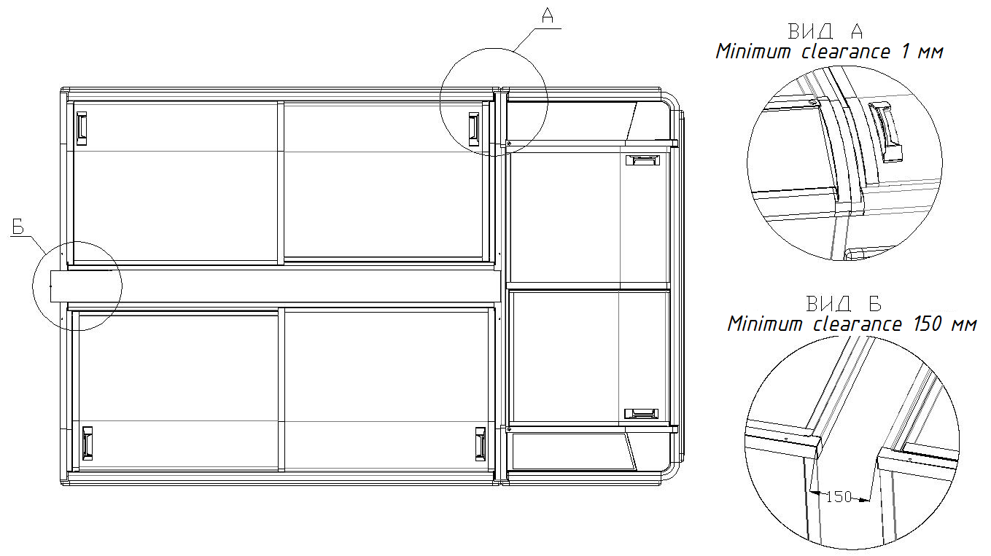
Failure to observe the above installation rules may result in chest performance issues and increased energy consumption.
4.6. Screw in the feet (bolts) and use them to set the product horizontally (check with the level). The chest shall not rock.
4.7. A protective film is applied to body elements and shall be removed.
4.8. Wash the inner surfaces of the product and the glass with a soft detergent and wipe dry.

- ELECTRIC CONNECTIONS.

SAFETY

5.1. The product meets the general safety requirements in accordance with GOST R 52161.1-2004, GOST R 52161.2.24-2007, GOST 23833-95, GOST 14254-96.
5.2. The supply voltage shall be within the range of minus 15% to plus 10% of rated voltage in accordance with GOST 13109.
Note: In case your area experiences voltage variations exceeding the specified values, it is advised to connect the product to the mains power supply through special protective devices.
5.3. The product has a power cable with a ground conductor and a plug with a ground contact.
5.4. The product shall be connected to the power supply via a Euro socket (10A) with a ground contact.
Note: Do not operate the equipment with missing or faulty protective grounding.

OPERATING AND MAINTENANCE MANUAL

6.1. The chest starts working immediately upon connecting the product to the power supply (inserting the plug). The chests are already equipped with internal lighting. Each chest shall have an additional light socket.
IMPORTANT If transported at a temperature below +10 °C, the equipment shall be left at an ambient temperature of +18 °C to +25 °C for at least 4 hours before switching on.
The equipment shall be re-connected to the power supply system (after a forced shutdown) no earlier than 3-4 minutes thereafter.
6.2. The processes of unit operation and maintaining the temperature inside the chest, as well as defrosting the evaporator, are controlled by an electronic controller installed in the refrigerating unit compartment. Factory settings ensure optimal product operation. The electronic controller operating manual is enclosed with this data sheet.
6.3. Wiring diagram is shown in Figure 1.
6.4. Do not load the chest over the maximum loading lines to ensure its proper operation.
DO NOT exceed the loading limits!
Load the products only after the set temperature is reached in the cooled area of the chest.
IMPORTANT Products and convenience products shall be pre-cooled (for medium-temperature chests) and frozen (for freezer chests).
6.6. High ambient air temperatures in the room cause ice and frost to accumulate inside the chest compartment during operation. This is perfectly normal and does not interfere with the operation as long as the icing inside does not reach the extreme limit. IMPORTANT Excess ice and frost above the loading line shall be removed with a plastic scraper (standard accessory).
6.7. Frozen ice and frost are regularly melted automatically. The resulting melt water is discharged through the drain tray into the refrigerating unit compartment and evaporated. IMPORTANT When ice and frost build-up reaches about 1 cm, the chest shall be defrosted. In addition to the automatic defrosting system, which operates at a set time, it is possible to perform manual defrosting (see the Electronic Controller Operating Manual enclosed with this Data Sheet).
6.8. Products and convenience products shall be evenly arranged on display racks. The height of the product arrangement shall not exceed the height of the loading line. Loading rates shall conform to the ones specified in Table 1. Use display racks at all times. Do not remove them! The racks are used to create a gap between the products and the wall where evaporation occurs during defrosting. IMPORTANT Do not put the products on the bottom of the chest without display racks.
6.9. If there is an additional upper uncooled superstructure, the Manufacturer undertakes no responsibility for the allocation of products requiring cooling on the shelves of this superstructure.
6.10. Commissioning, adjustment of the refrigeration machine automation devices, maintenance and repair of the product shall only be performed by specialists of either the Manufacturer or organizations that have the appropriate authorization (license) by the Manufacturer for performing such work. Maintenance information shall be recorded in the Data Sheet (Appendix 2).
6.11 Maintenance.
Uninterrupted and effective operation of the products is ensured by a system of planned preventive measures for care, supervision, diagnostics and all types of repairs performed regularly within the established time frames and aimed at maintaining the equipment in serviceable condition.
List of Maintenance Works
Seq.  No. | Work description | Frequency | Executor
1 | Sanitary washing, cleaning of internal and external surfaces with fresh water with a temperature not exceeding 60 ⁰C and soft detergents. | weekly | Cleaning service  staff  of the owner company
2 | Cleaning dirt from the freezer components and dust from the condenser | weekly | Serviceman  of the owner company
3 | Inspection of the refrigerating unit, electrical measurements of network parameters, primary fault detection; automation device setting check | monthly | Service Center
4 | Assembly attachment reliability check, fastener tightening | monthly | Service Center
5 | Cleaning of electrical equipment and start-up protection equipment, checking the reliability of electrical connections, tightening them | quarterly | Service Center
6 | Automatic control device check | monthly | Service Center
7 | Inspection for the presence of refrigerant leaks, eliminating them (as necessary) | monthly | Service Center

IMPORTANT When performing sanitary treatment, preventive maintenance and repair work, the product shall be disconnected from the power supply by removing the plug from the socket, and the products shall be removed from the cooled area.
IMPORTANT Do not wash the product under running water, as accidental contact of moisture with electrical parts can disrupt the normal operation of the product and the electrical safety system.
IMPORTANT Do not use sharp objects to remove ice or frost! Risk of damage to the internal walls. Use a plastic scraper (standard accessory).
IMPORTANT Do not use sharp or pointed objects to clean the drain! Collect the water with a wet-dry vacuum cleaner, cloth, or sponge. Wipe the chest dry, clean the inner surface.
IMPORTANT Sliding glass covers are made of tempered, heat-reflecting glass. Special lubricant is applied to the frame guides. In order to maintain smooth cover sliding, clean the frame from dirt and dust and re-lubricate the frame guides from time to time.
IMPORTANT If a light bulb is broken, carefully collect the fragments inside the chest and check the products for the absence of glass shards.
6.12. Do not move or rearrange display chests by dragging, holding by the body.
IMPORTANT When being moved, the product shall be disconnected from the power supply by removing the plug from the socket, and the products shall be removed from the cooled area.
6.13. To move the chest, use a loader, a stacker, or a transport cart.
6.14. Chest shall be transported packaged and in an upright position only. Prior to transportation, secure the packaged chest to prevent bumps and movement inside the vehicle. Do not mount more than 3 packaged chests on top of each other.
6.15. IMPORTANT Do not step on the glass cover and do not put anything thereon! The glass cover is not intended to be used as a support for accessing high shelves or for placing various items thereon, and is not designed for such loads.
6.16. List of critical failures

Seq.  No. | Failure description | Possible causes
1 | Automatic protection triggered when the chest is turned on | 1. Integrity of wiring insulation in the chest body is violated  2. Circuit breaker malfunction.  3. Unauthorized chest wiring modification.
6.17. Possible errors by the employees.

Seq.  No. | Employee actions description
1 | Performing a controller configuration different from the factory setting.
2 | Loading of products over the specified loading level.
3 | Loading the chest with uncooled products.
4 | Temperature and humidity air conditions in the room where the chest is installed are violated.

- STORAGE, TRANSPORT AND HANDLING

7.1 Storage, transport and handling shall be performed in accordance with GOST 23833-95, clause 9, Transportation and Storage, taking into account the handling marks on the equipment packaging.
7.2 During storage, the safety and integrity of the equipment, as well as of the components packed in accordance with the technical documentation of Ariada, CJSC shall be ensured.
7.3 Storing equipment in the open air, exposure of unprotected structural elements to direct sunlight, precipitation, etc. are strictly prohibited.
8. ACCEPTANCE AND PACKING CERTIFICATE

Freezer chest:
Serial Number:
Compressor manufacturer (brand):
Compressor model:
Compressor No.:
Conforms to
– TR CU 010/2011 On Safety of Machines and Equipment in part of GOST 23833 Section 6, GOST R 52161.1, GOST R 52161.2.24 requirements observance;
– TR CU 004/2011 On Safety of Low-Voltage Equipment in part of GOST 14254 requirements observance;
– TR CU 020/2011 Electromagnetic Compatibility” in part of GOST R 51318.14.1, GOST R 51318.14.2, GOST R 51317.3.2, GOST R 51317.3.3 requirements observance.
– Technical Specifications TU 28.25.13-030-12906390-2019

The MANUFACTURER has provided

The Declaration of Conformance: EEU N RU Д-RU.КА01.В.13263/19
Validity: August 29, 2019 through August 28, 2024.

The packaging complies with the technical documentation.

Issue date

L.S.

Person responsible for acceptance

Manufacturer: Ariada, CJSC, 1 Prombaza st., Volzhsk, the Republic of Mari El,
425000, Russia.
Mailing address: PO box 25, Volzhsk, the Republic of Mari El, 425000, Russia.
Telephone: 8(83631) 43133; Fax: 8(83631) 43133, 43045

E-mail: info@ariadal.ru ; http:// www.ariada.ru
9. WARRANTY

9.1. Warranty shall be provided for free elimination of factory defects, the credibility of which is recognized by the Manufacturer or a specialized organization specified in the Data Sheet. Warranty obligations can be fulfilled by a specialized organization that has a relevant agreement with the Manufacturer.
9.2. The warranty period for the product is set by the Manufacturer and is 12 months from the date of actual shipment of the product from the Manufacturer.
9.3. Warranty does not apply if:
- all the rules of transport, handling, storage, installation and operation specified in the Data Sheet were not fulfilled;
- commissioning, adjustment of the refrigeration machine automation devices are performed by an organization having no written authorization for such work;
- there is no contract available on product maintenance by a specialized organization with relevant certification;
- the product has been modified or repaired without the written consent of the manufacturer.
9.4. The product warranty does not cover maintenance during the warranty period, which is paid separately.
9.5. Commissioning shall be performed by any of the specialized organizations with the appropriate certification.
9.6. The Customer shall enter into a Maintenance Contract with any specialized organization specified in the equipment Data Sheet, within 30 days upon product delivery.
9.7. The warranty applies only if the following documents are available:
- Commissioning Certificate (Appendix 1);
- Mechanical Condition Report;
- Contract on product maintenance by a specialized organization with the relevant certification.
The Certificates shall be signed by the Customer, a specialized organization and certified with the appropriate seals. The absence or failure to provide the Manufacturer or a specialized organization that has the right to perform product warranty repairs, the above documents, entitles the latter to refuse to fulfill the warranty obligations.
9.8. The warranty does not cover units and parts of glass, as well as lighting equipment.
9.9. In case the Manufacturer's specialists or a specialized organization that has the right to perform warranty repairs establish the facts that indicate the Customer's fault in the product failure, the latter undertakes to pay all the costs that the above organizations incurred when providing specialists. Therewith, the obligation to prove the absence of guilt lies with the customer.
9.10. The warranty period is not extended in case of repair or replacement of parts and components.
9.11. Full average service life – at least 12 years. Upon expiry of the standard service live of the product, the accredited service center shall conduct a procedure on assessing its technical condition and decide on the acceptability, parameters and conditions of its further operation.

10. Disposal.

10.1. 10.1 In accordance with the waste disposal regulations in force in each individual country, if a refrigerated freezer chest is disposed of, it shall be dismantled so that its parts can be disposed of or recovered accordingly. The components shall not be considered as solid urban waste.

10.2. The following materials were used in the manufacture of the chest freezer:

- Galvanized steel: chest outer body.

- Aluminum sheets: chest lining

- Stainless steel: lamp reflector.

- Metal profiles and pipes: lower frame.

- PVC profiles: shockproof profiles.

- PU foam (polyurethane foam): thermal insulation.

- Glass: sliding glass covers.

- Plastic: body parts.

10.3. The equipment applies a refrigerant with a greenhouse waste potential (GWP). Therefore, cutting and/or separating the components of the cooling circuit is prohibited, such components shall be transferred in their entirety to specialized centers for the cooling gas recovery.
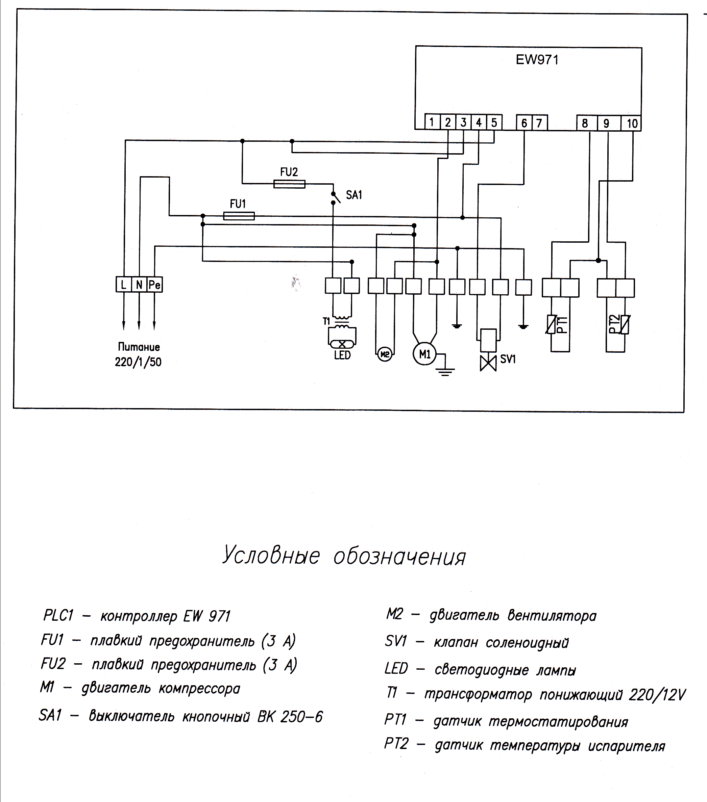
Electrical symbols
PLC1 – controller EW 971 | M2 – fan motor
FU1 – fuse (3 А) | SV1 – solenoid valve
FU2 – fuse (3 А) | LED – LED lamp
М1 – compressor motor | Т1 - step down transformer
SA – key switch BK 250-6 | PT1 – temperature control sensor
 | PT2 – evaporator temperature sensor

Fig.1. Wiring diagram for chests LL(M)(U)1-185,

LL(M)(U)1-210, LL(M)(U))1-250.

Note: The Manufacturer reserves the right to introduce minor changes to the product electrical circuit and design that do not impair the technical characteristics of the product, without reflecting such changes in this Data Sheet.

Appendix 1

Commissioning Certificate

This Certificate is drawn up on ___________ ___ 20___ by the Freezer Chest owner_________________________________________________________________ ________________________________________________________________________
Name and address, position, full name
and a representative of a specialized organization that the Freezer Chest _____________ Serial No._____________ manufactured by Ariada, CJSC on ____________ ___, 20___ is commissioned by an electrician of____________________________________________________
Name of the organization, full name

Certificate on the right to install and maintain commercial refrigeration equipment No.__________ issued ___________ ____, 20___ by
_______________________________________________________________________
Name of the organization having issued the certificate
Owner __________ _________________
Signature Full name

Representative of a specialized organization ________ ______________
Signature Full name

L.S.

Appendix 2

Information on maintenance and repair works performed during the warranty period.

Maintenance  date | Maintenance  result  (seal of the Service Center) | Maintenance  date | Maintenance  result  (seal of the Service Center)

